How do we avoid Inheritance, how do we avoid abstract keywords, or how do we avoid the OOPs principle in a class?
The answer is by using the static keyword. So, you need to mark the CommonTask class as static by using the static keyword. When you mark a class as static, everything inside the class should be static
- Use Static Class

OOPs, provide 4 principles. They are
1. Encapsulation
2. Inheritance
3. Polymorphism
4. Abstraction

C# Abstraction
Data abstraction is the process of hiding certain details and showing only essential information to the user.
Abstraction can be achieved with either abstract classes or interfaces (which you will learn more about in the next chapter).
The abstract keyword is used for classes and methods:
• Abstract class: is a restricted class that cannot be used to create objects (to access it, it must be inherited from another class).

• Abstract method: can only be used in an abstract class, and it does not have a body. The body is provided by the derived class (inherited from).
Why And When To Use Abstract Classes and Methods?
To achieve security - hide certain details and only show the important details of an object.
// Abstract class
abstract class Animal
{
// Abstract method (does not have a body)
public abstract void animalSound();
// Regular method
public void sleep()
{
Console.WriteLine("Zzz");
}
}

// Derived class (inherit from Animal)
class Pig : Animal
{
public override void animalSound()
{
// The body of animalSound() is provided here
Console.WriteLine("The pig says: wee wee");
}
}

class Program
{
static void Main(string[] args)
{
Pig myPig = new Pig(); // Create a Pig object
myPig.animalSound(); // Call the abstract method
myPig.sleep(); // Call the regular method
}
}
The pig says: wee wee
Zzz
The process of binding the data and functions together into a single unit (i.e. class) is called Encapsulation. In simple words, we can say that it is a process of defining a class by hiding its internal data members from outside the class and accessing those internal data members only through publicly exposed methods or propertie
To achieve "Encapsulation" - which is the process of making sure that "sensitive" data is hidden from users. This is done by declaring fields as private
The meaning of Encapsulation, is to make sure that "sensitive" data is hidden from users. To achieve this, you must:
• declare fields/variables as private
• provide public get and set methods, through properties, to access and update the value of a private field
A property is like a combination of a variable and a method, and it has two methods: a get and a set method:

C# Inheritance
class Vehicle // base class (parent)
{
public string brand = "Ford"; // Vehicle field
public void honk() // Vehicle method
{
Console.WriteLine("Tuut, tuut!");
}
}

class Car : Vehicle // derived class (child)
{
public string modelName = "Mustang"; // Car field
}

class Program
{
static void Main(string[] args)
{
// Create a myCar object
Car myCar = new Car();

// Call the honk() method (From the Vehicle class) on the myCar object
myCar.honk();

// Display the value of the brand field (from the Vehicle class) and the value of the modelName from the Car class
Console.WriteLine(myCar.brand + " " + myCar.modelName);
}
}
Tuut, tuut!
Ford Mustang
The process by which the members of one class are transferred to another class is called inheritance.
C# Polymorphism
Like we specified in the previous chapter; Inheritance lets us inherit fields and methods from another class. Polymorphism uses those methods to perform different tasks. This allows us to perform a single action in different ways.
So, the word polymorphism means the ability to take more than one form.
we can say that when the same function/operator will show different behaviors by taking different types of values or with a different number of values called Polymorphism. There are two types of polymorphism
1. Static polymorphism/compile-time polymorphism/Early binding
2. Dynamic polymorphism/Run time polymorphism/Late binding

Static polymorphism is achieved by using function overloading and operator overloading whereas dynamic polymorphism is achieved by using function overriding.

class Animal // Base class (parent)
{
public void animalSound()
{
Console.WriteLine("The animal makes a sound");
}
}

class Pig : Animal // Derived class (child)
{
public void animalSound()
{
Console.WriteLine("The pig says: wee wee");
}
}

class Dog : Animal // Derived class (child)
{
public void animalSound()
{
Console.WriteLine("The dog says: bow wow");
}
}

class Program
{
static void Main(string[] args)
{
Animal myAnimal = new Animal(); // Create a Animal object
Animal myPig = new Pig(); // Create a Pig object
Animal myDog = new Dog(); // Create a Dog object

myAnimal.animalSound();
myPig.animalSound();
myDog.animalSound();
}
}

The output will be:
The animal makes a sound
The animal makes a sound
The animal makes a sound

That is because the base class method overrides the derived class method, when they share the same name.
However, C# provides an option to override the base class method, by adding the virtual keyword to the method inside the base class, and by using the override keyword for each derived class methods:
class Animal // Base class (parent)
{
public virtual void animalSound()
{
Console.WriteLine("The animal makes a sound");
}
}

class Pig : Animal // Derived class (child)
{
public override void animalSound()
{
Console.WriteLine("The pig says: wee wee");
}
}

class Dog : Animal // Derived class (child)
{
public override void animalSound()
{
Console.WriteLine("The dog says: bow wow");
}
}

class Program
{
static void Main(string[] args)
{
Animal myAnimal = new Animal(); // Create a Animal object
Animal myPig = new Pig(); // Create a Pig object
Animal myDog = new Dog(); // Create a Dog object

myAnimal.animalSound();
myPig.animalSound();
myDog.animalSound();
}
}

The output will be:
The animal makes a sound
The pig says: wee wee
The dog says: bow wow

C# Method Overloading
You can perform method overloading in C# by two ways:
1. By changing number of arguments add(int a,int b) & add(int a, int b, int c)
2. By changing data type of the arguments add(float a, float b) & add(int a, int b)
To perform method overriding in C#, you need to use virtual keyword with base class method and override keyword with derived class method.
Because of = > Same class name and everything same

Types of Inheritance
According to C++, why I am telling about C++ is because Object-Oriented Programming came into the picture from C++ only, there are five different types of Inheritances.
- Single Inheritance
- Multi-Level Inheritance
- Hierarchical Inheritance
- Hybrid Inheritance
- Multiple Inheritance

Hierarchical Inheritance:
When more than one derived class is created from a single base class then it is called Hierarchical inheritance.

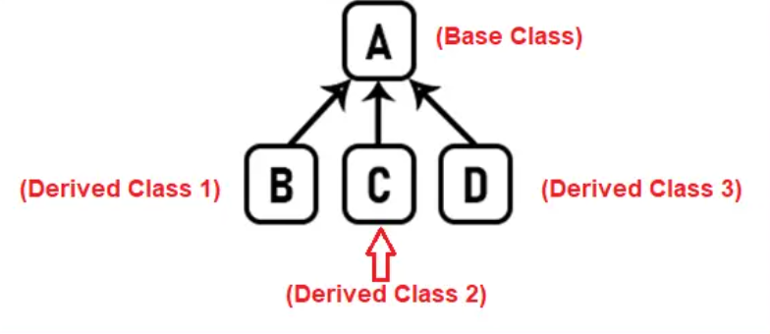

Multiple Inheritance:
When a derived class is created from more than one base class then such type of inheritance is called multiple inheritances.

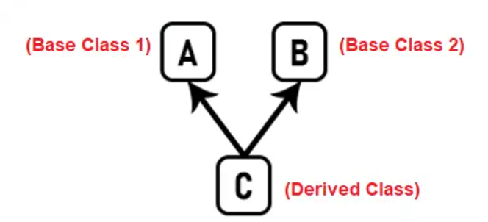

Hybrid Inheritance:
Hybrid Inheritance is the inheritance that is the combination of any Single, Hierarchical, and Multilevel inheritances.

